公司简介
惠州惠菱化成有限公司（以下简称公司）成立于2004年3月16日，是世界上最大的运用C₄直接氧化法生产甲基丙稀酸甲酯（MMA）单体的工厂之一。投资方是日本三菱丽阳株式会社，总投资为13,210万美元。项目位于广东省惠州市大亚湾经济技术开发区石油化学工业区,占地面积134,514m²。主体装置由日本引进，具有低投入、低能耗、低污染、低毒性等特点。工厂以中海壳牌抽余油－1中的异丁稀为原料，采用MRC自行研制的、国际上先进的C₄直接氧化法生产工艺，日产MMA单体200多吨，生产能力已达到年产90,000吨，成为中国市场上MMA单体最重要的生产商之一。
经营理念：追求最高品质，为人类丰富多彩的未来做出贡献！ 我们力争将公司建设成为生产和提供具有独特性﹑优越性﹑社会性产品和服务的企业！
经营目标：提供高性能﹑高品质﹑低成本的优良产品，从事对地球环境有益的生产活动。我们将谋求与当地社会的共同生存与发展，优先考虑环境保护和确保安全生产事宜，推进业务活动的展开。
安全、环境、质量保证的基本方针：安全、环境是企业生存的必要条件，应优先其他事业采取行动；我们给顾客提供的是满意、放心、值得信赖的产品。
企业社会责任（CSR）五项原则：遵章守纪，执行企业伦理规范； 注重安全与环保，积极推进安全、环保活动；以顾客为导向，提供最优质的产品和服务；重视利益相关者，与社会和谐共处；尊重人权，重视每一位员工。
公司遵循三菱丽阳集团的理念，按照企业所处经济社会的结构变化，企业活动的国际化发展和企业的社会责任，发展成为一个长久有益于社会的企业。在日常的业务活动中,我们首先考虑遵守法律法规,遵循社会道德,以使企业在赢得社会的信赖，同时实现持久繁荣。
Company Profile
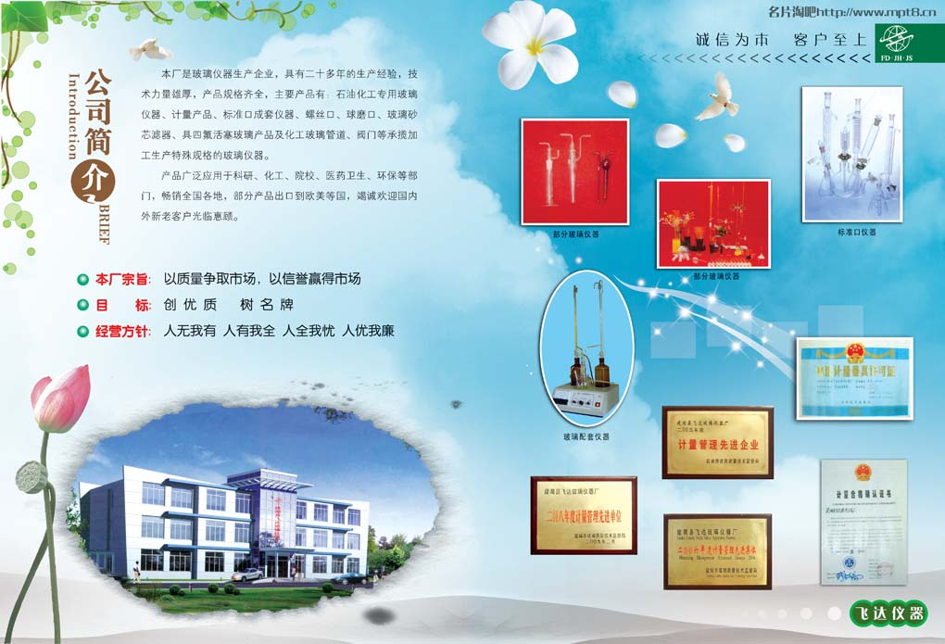
Huizhou MMA Co. Ltd. (HMC), established on March 16th, 2004, is the largest MMA monomer manufacturer in the world invested by Mistuibishi Rayon Group (MRC) with the total investment being USD13,210. HMC is located in Daya Bay Economic and Technical Development Zone, Huizhou City, Guangdong Province and it covers an area of 134,514 square meters. The Plant uses isobutene of Raff-1 from CSPC as raw material and adopts the advanced MRC-developed C₄-Oxidation Technology, which is of low cost, low energy consumption, low pollution and low toxicity. The main equipment is imported from Japan and is operated by central control system, the automation level of which is high. Nowadays, the daily production of MMA monomer exceeds more than 200 tons and the output increases to 90,000 tons. HMC has become one of the leading MMA monomer suppliers in China’s market.
Management Philosophy
In keeping with the management philosophy encapsulated in our watchword “Best Quality for a Better Life”, we are committed to the creation of unique, high-quality products and services that contribute to the good of society as a whole.
HMC Mission
Our mission is to supply high-performance, high-quality products at low cost while minimizing the environmental burden of its production operations. In addition to priority on environmental preservation and safety, we also put a strong focus on maintaining good relations with the local communities around our production centers.
Basic SEC Philosophy
Being safe and environmental, as the necessity of HMC’s development, is always regarded as the first position. And HMC will provide high-quality, safe and reliable products for our customers.
Corporate Social Responsibility
- Compliance, Implementation of business ethics
- Focus on safety and environmental protection and actively promote the safety, environmental protection
- Provide the best quality products and service.
- Concern stakeholders and social harmony
- Respect human rights and value every employee
HMC follows the philosophies of MRC and will become an enterprise which will benefit to society for a long time. In order to win the society trust and long term prosperity, HMC regard corporate ethics and legal compliance as top-priority management issues. Campus Recruitment校园招聘

We offer long-term career development opportunities, good salary package and welfare to talented people who have team spirit and strong intention to improve themselves. Come to us and start your international experience and successful career in HMC! Motivated candidates please send your resume in both English and Chinese to us. Please refer to the following for more details.
我们诚邀积极向上、富有团队合作精神的有志之士加盟！有关职位招聘详细信息请参阅下面内容。

拟招职位
- Field Operator现场操作员
联系方式：
地址：广东省惠州市大亚湾经济开发区石油化学工业区滨海十一路8号
邮编：516082
传真：（0752）559 8371
收件人：惠州惠菱化成有限公司总务课
电子邮件：job@hzhmc.com

Job Description 职位描述
Field Operator现场操作员
Section/Dept.: Production Section, Production Dept.

Duties Specific
- Operate HMC plant through field work on day/ night shift following direction of Shift supervisor/CCR officer.
- Manipulate equipment and valves, following direction of Shift Supervisor/CCR Officer to operate HMC plant smoothly.
- Execute all necessary work at field to operate HMC plant continuously.
- Follow the safety standards and operating standards.
- Communicate with Shift Supervisor/CCR Officer closely to make operation effective.
- Execute routine plant inspection and routine work at field to find out potential safety and reliability problems.
- Report operation condition to Shift Supervisor/CCR Officer immediately when some trouble happens or some strange symptoms are observed, and take action promptly following their direction.
- Report conditions of operation and equipment to next shift.
- Understand not only operation standard but also HMC company philosophies of business and safety.

Qualification/Experience and Education
- College degree with major in chemical technology and engineering, chemical machinery, chemical engineering or other chemical related.
- Hard working attitude and able to work under pressure.
- Strong intention to make an effort to improve his ability and to keep safety.
- Good communication and interpersonal skills.
- Good team player with the ability and willingness to work closely with others.
- Proficient in computer skills, familiar with office software.
- Physically strong and healthy.
- English communication ability is preferable.

岗位职责：
- 在轮班主管或中控室技术员领导下，工作实行四班两倒制。
- 熟练控制和操作工厂设备和阀门。
- 执行现场的日常操作以确保工厂正常运行。
- 遵守安全和操作方面的规定。
- 能与轮班主管或中控室技术员及时沟通。
- 在车间现场工作或执行例常检查，及时找出安全隐患和设备故障。
- 发现问题或异常情况，立即向领班主管或中控室技术员汇报，并在他们的指导下及时解决问题。
- 向下一班操作员汇报当班情况。
- 理解操作规范及公司经营和安全理念。

职位要求：
1、化学工程与工艺、高分子材料与工程等相关专业，专科以上学历。
2、遵纪守法、爱岗敬业、吃苦耐劳、敢于承受工作压力。
3、具有责任心和安全意识。
4、具良好沟通能力以及团队合作精神。
5、电脑操作熟练，熟悉 OFFICE等办公软件。
6、身体健康。
7、懂英语者优先。

报名和面试情况：
1．报名时间：2011年5月20日下午5:00前；
2．报名地点：各班班长或辅导员处
4．面试时间地点：待定；

